Step:1 DOWNLOAD JENKINS .WAR FILE

LINK: <https://www.jenkins.io/download/>

(DON’T CHOOSE WINDOWS INSTALLER)

Step:2 MOVE YOUR FILE TO

C:/ProgramFiles

Step:3 OPEN CMD AND MOVE TO C:/ProgramFiles

* Cd..
* Cd..
* Cd ProgramFiles

Step:4 Check The Java Version

* Java –v

Or Java –version

Note: Jenkins will work only with java 8 or 11 , if your machine has java 8 or 11 you can directly run Jenkins by executing below command

* Java –jar jenkins.war

But if you machine don not have java 8 or 11 download it first and give the path like below

* . \Java\jdk1.8.0_202\bin\java –jar Jenkins.war

Once you will run the command Jenkins will start automatically and you will get secreat code as below

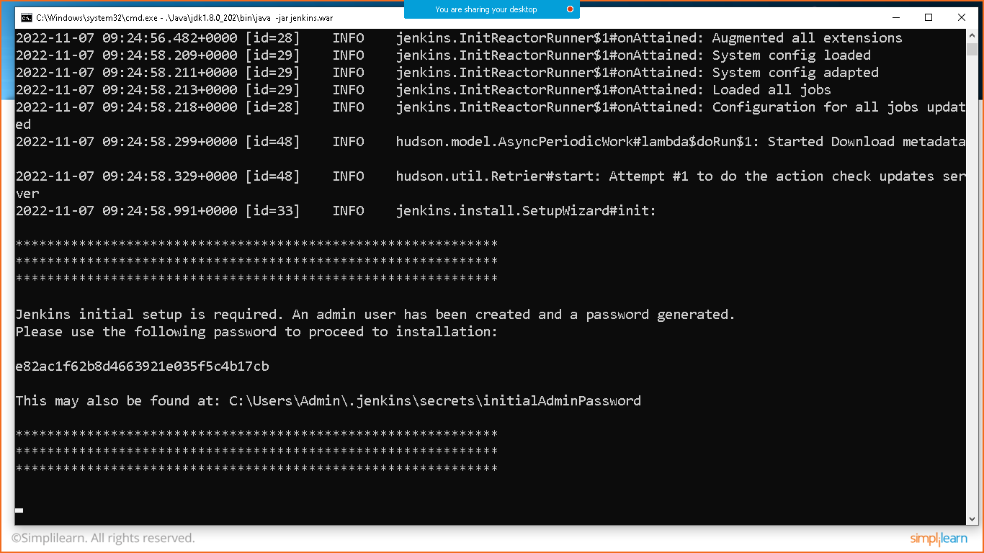

Goto the browser and type: localhost:8080 and hit enter

Copy the secret code and click on continue

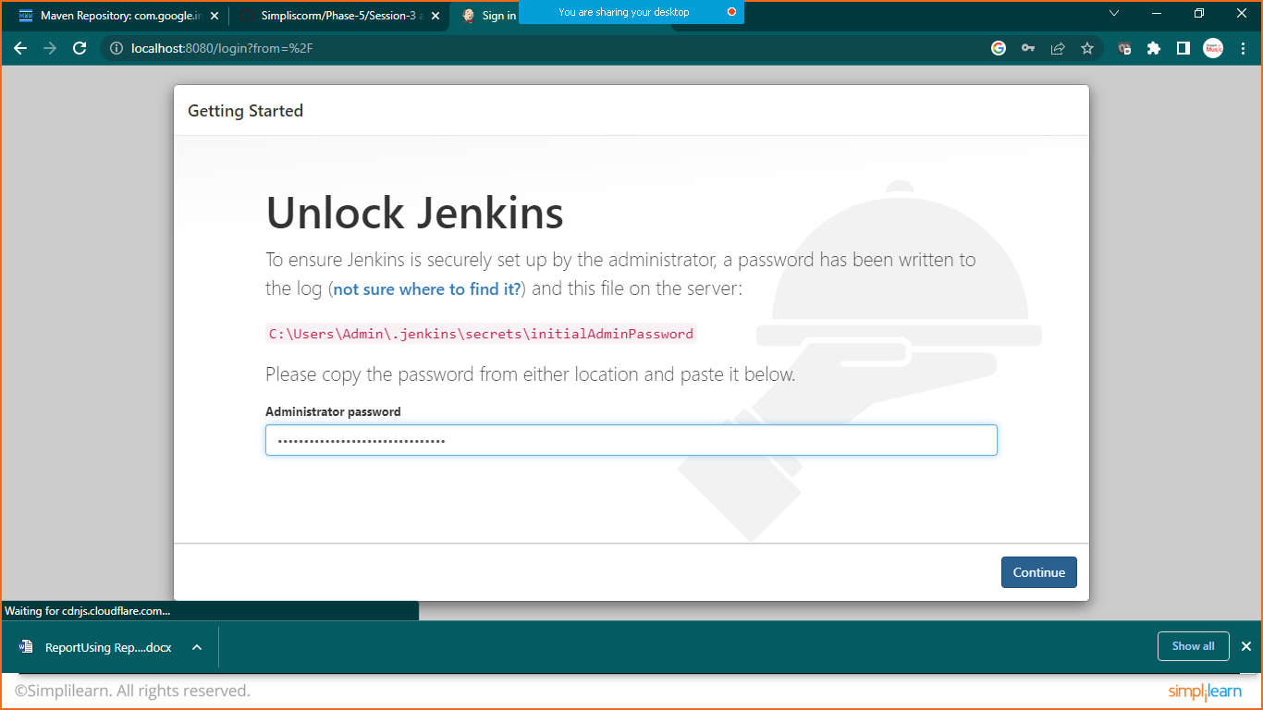

Click on install suggested plugins

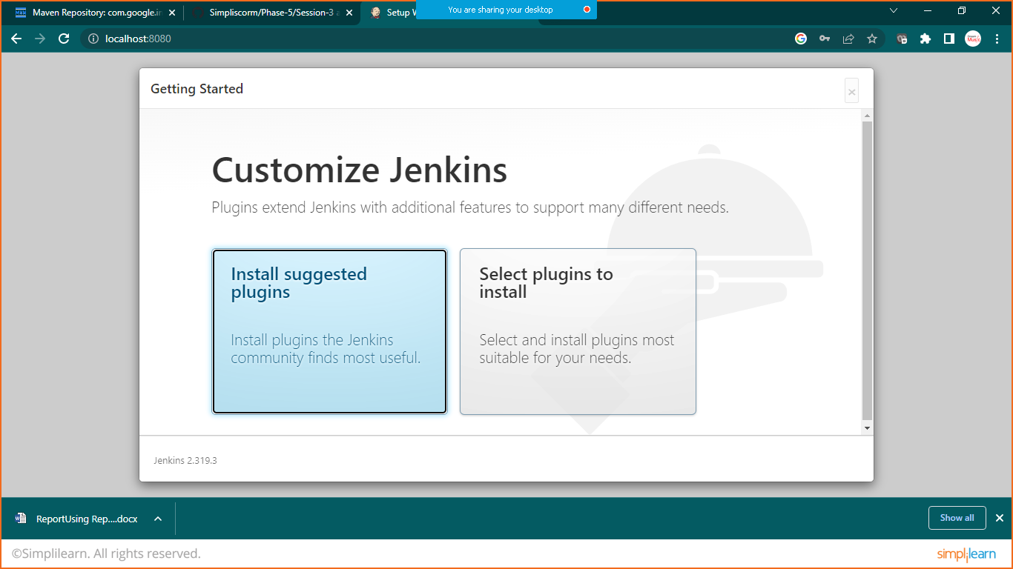

Wait until installation get completed

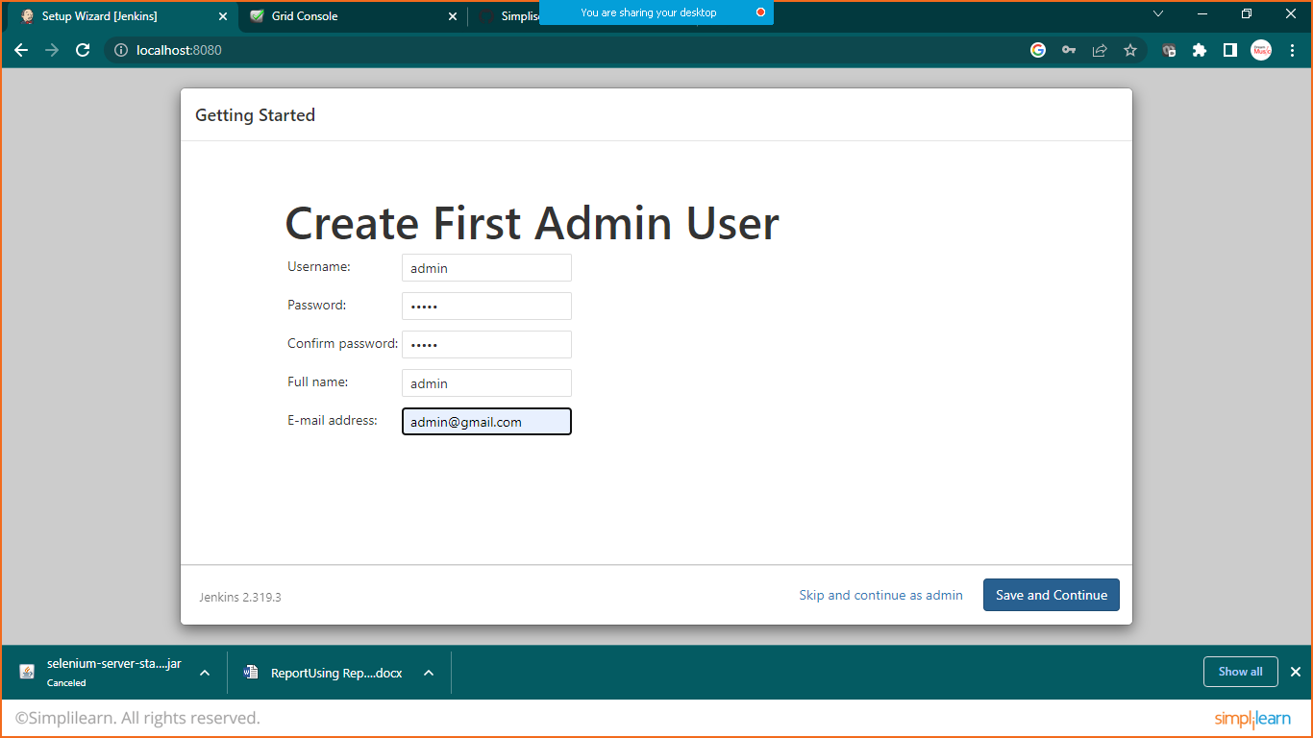

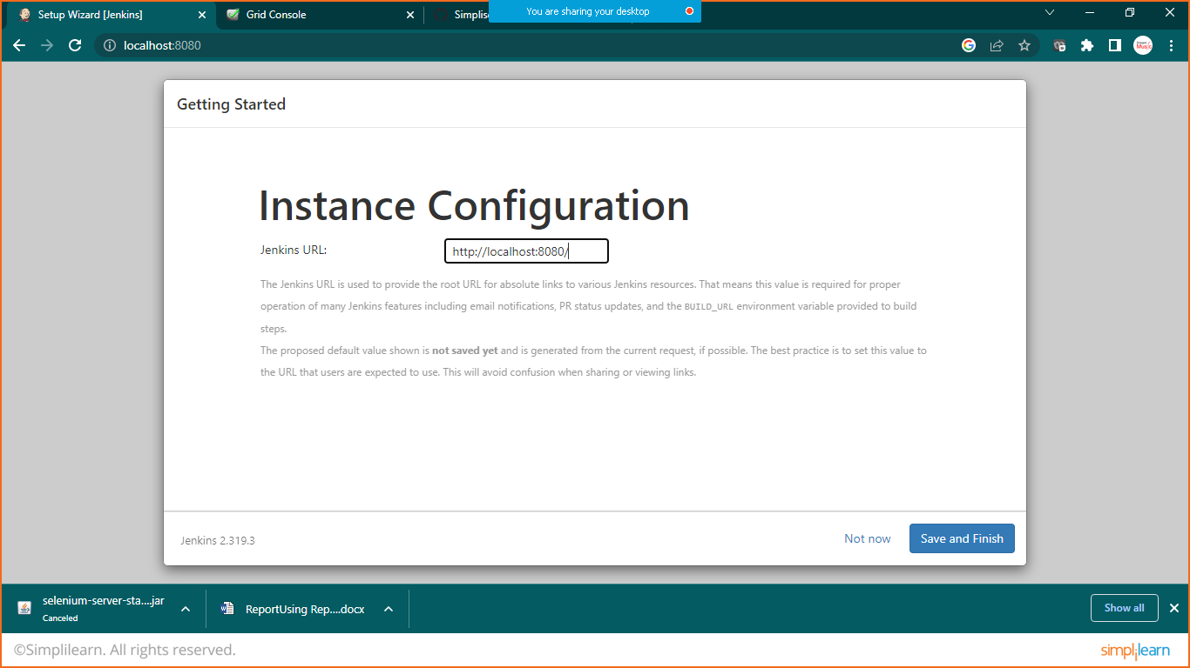

Click on save an continue

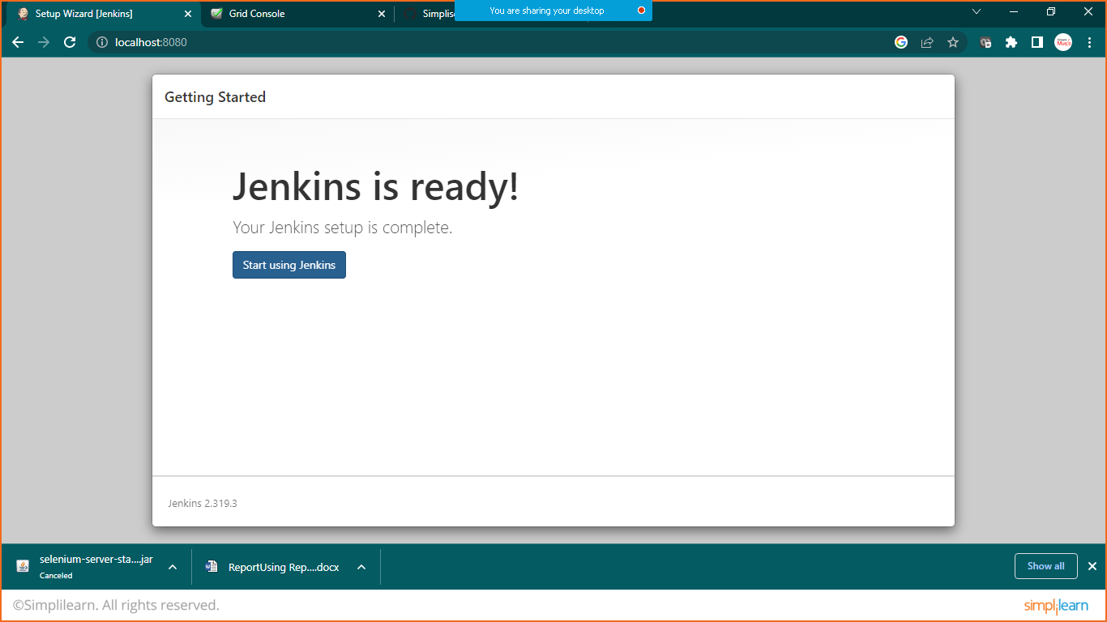

Click on manage plugins

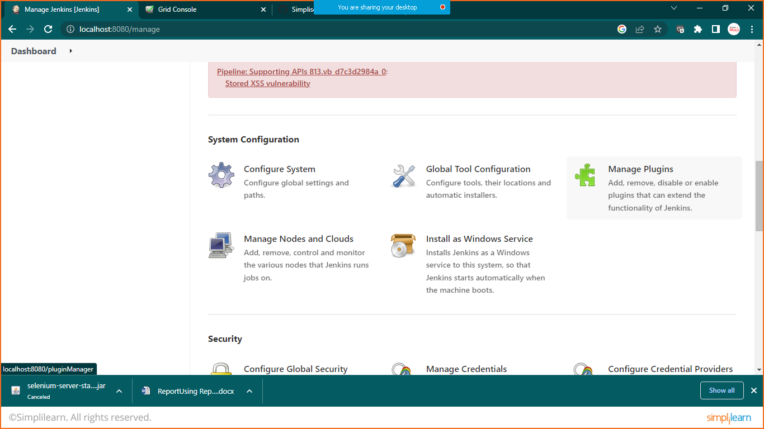

Search for maven integration

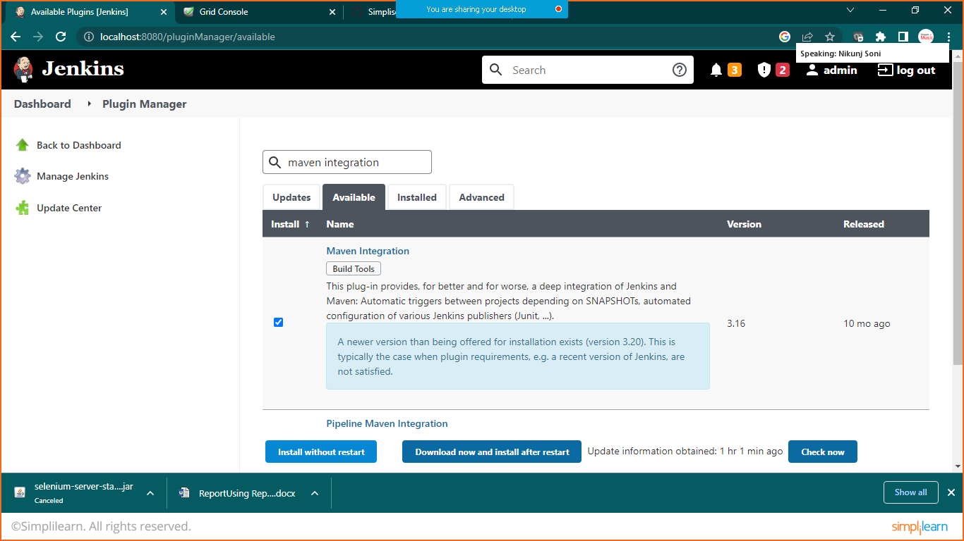

Choose install without restart

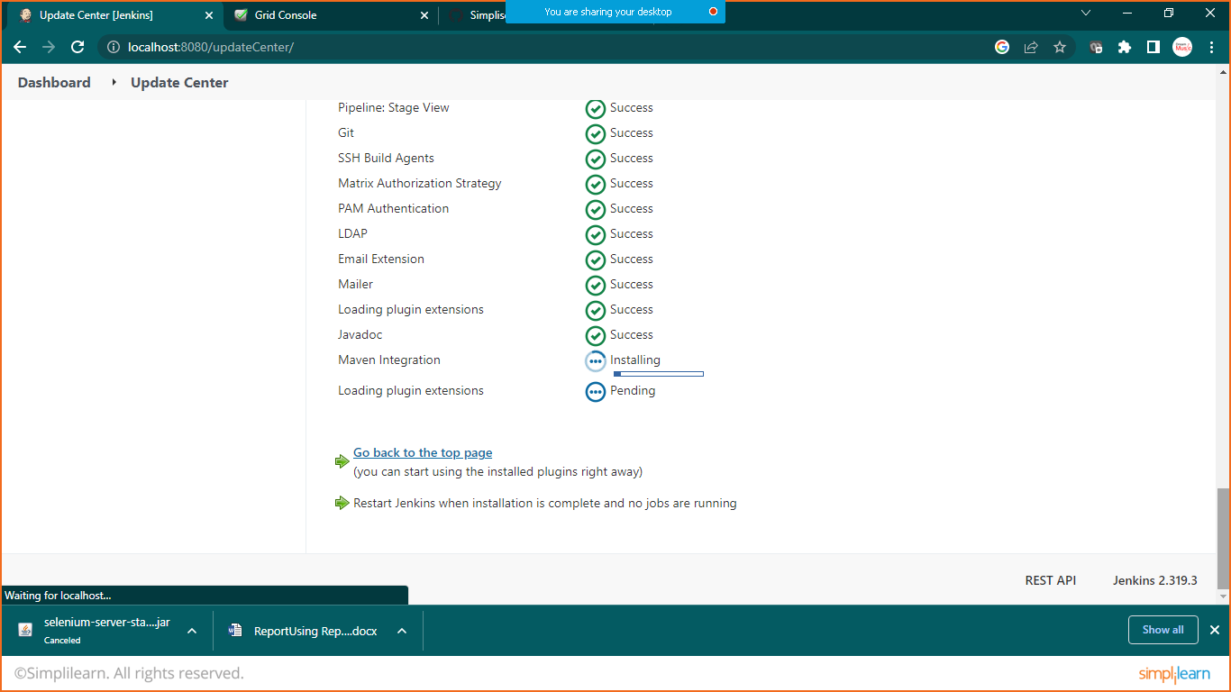

Again click manage Jenkins and click on global tool configuration

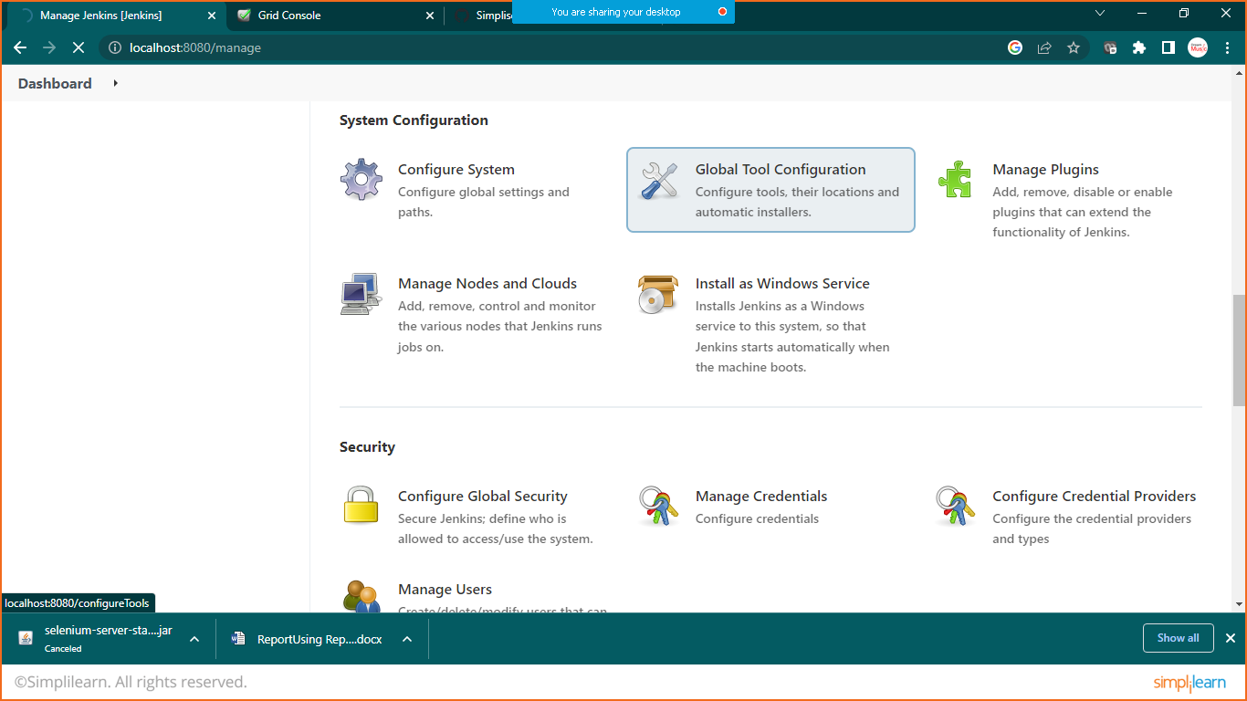

Provide your java path

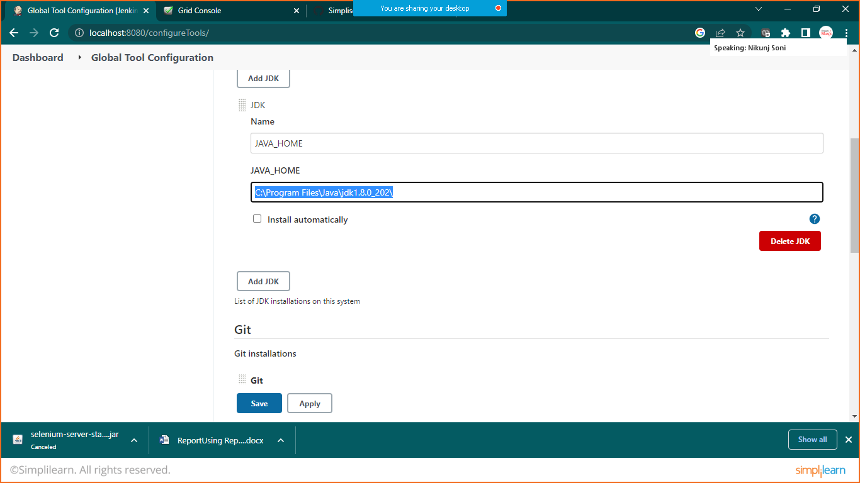

Also scroll down to maven

Goto> eclips>windows>preferences>maven>installation> check your maven version

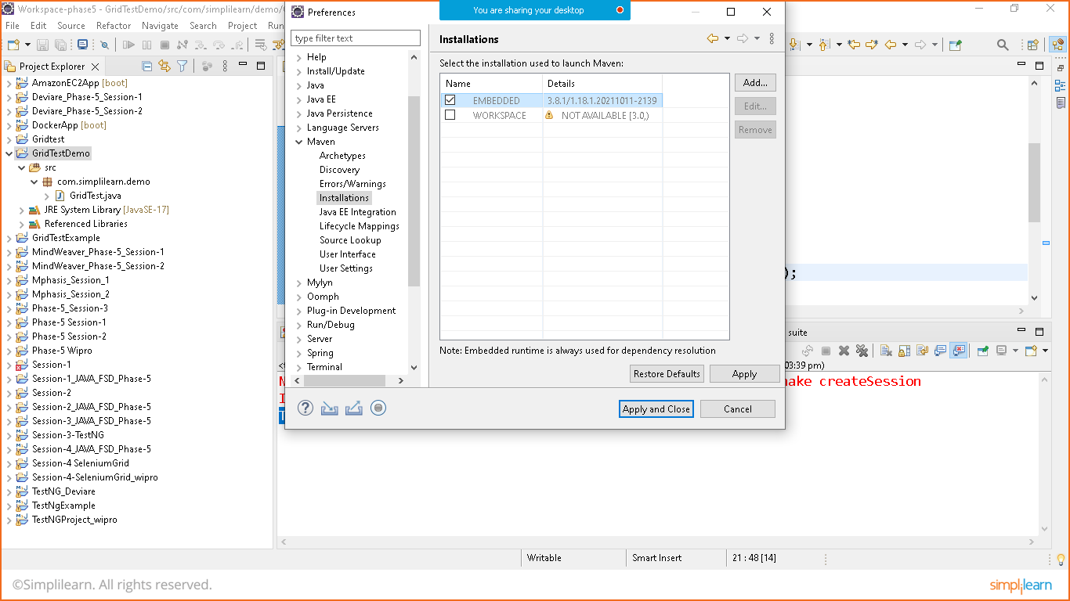

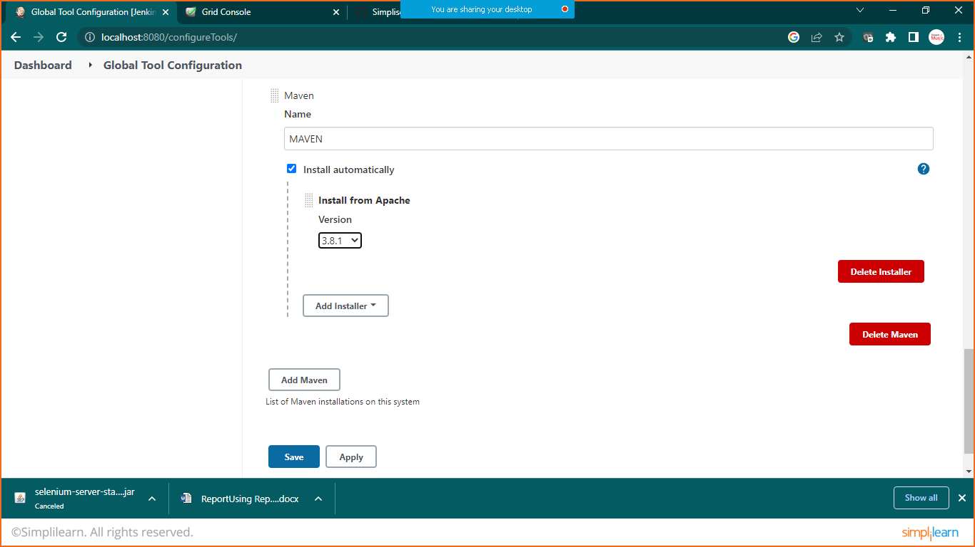

Click on apply and save

Create new job

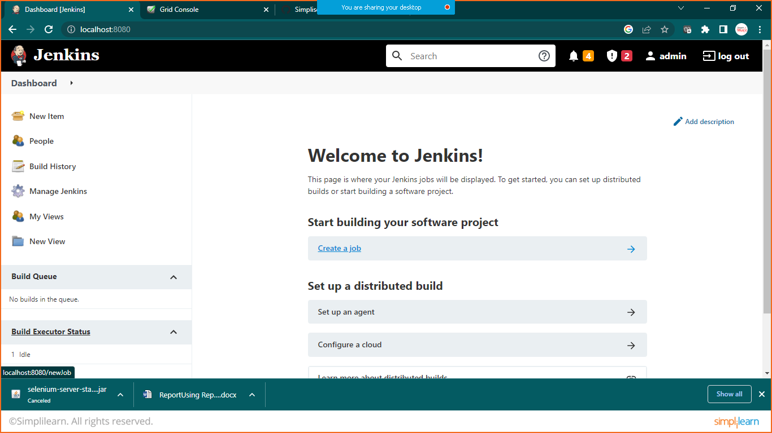

Prepare first maven project

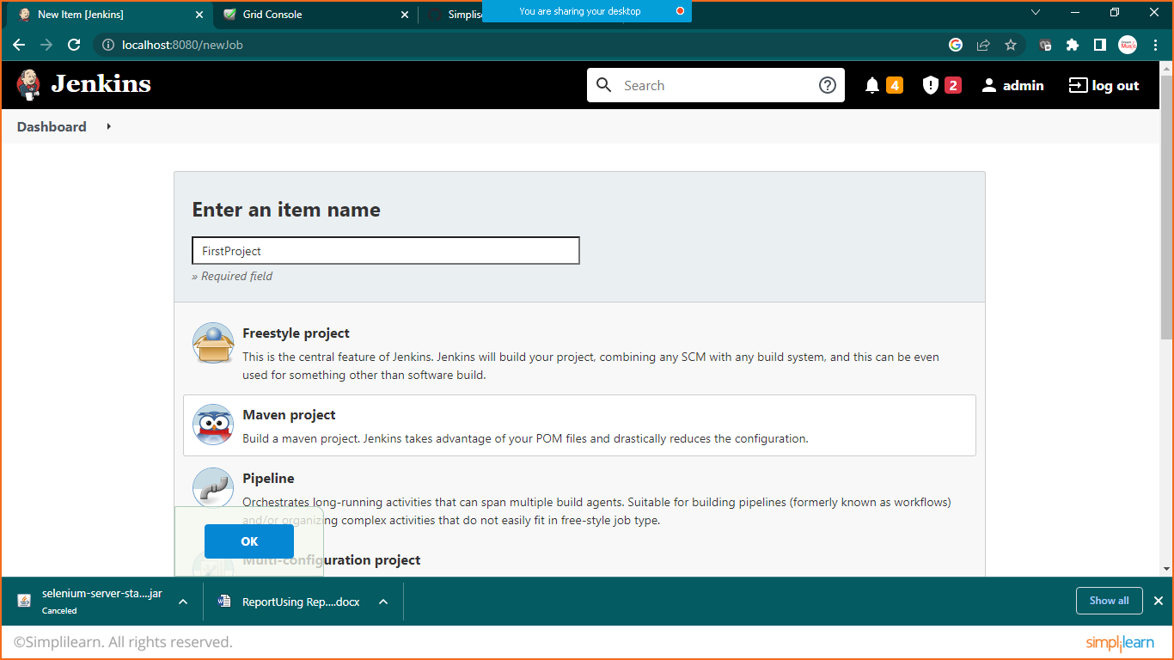

Give the path of pom.xml file of your project here

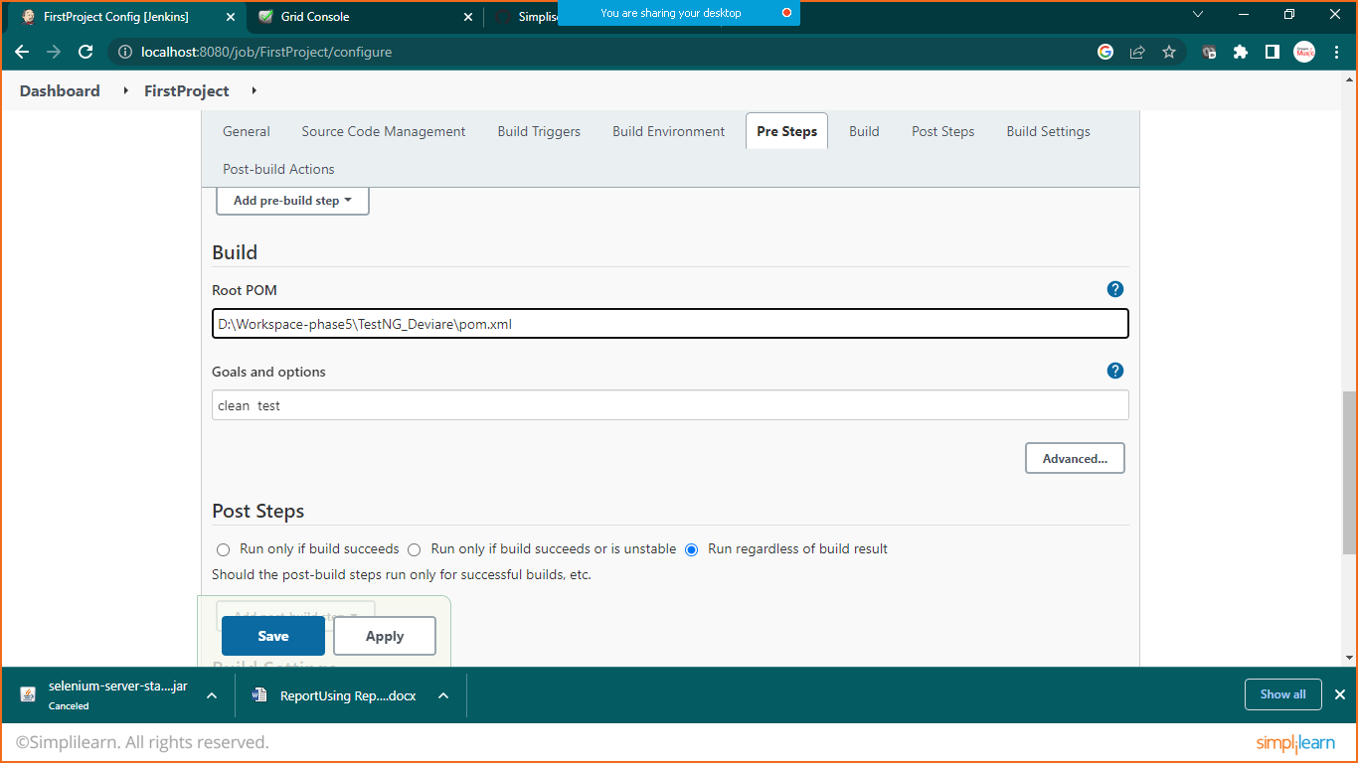in goal and option write: clean test

Click on save

Click on Build Now

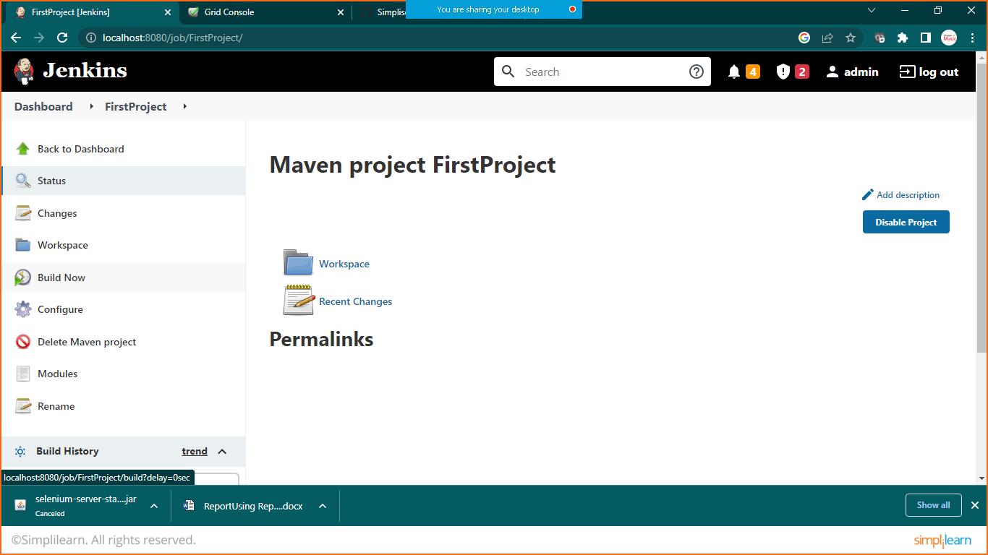

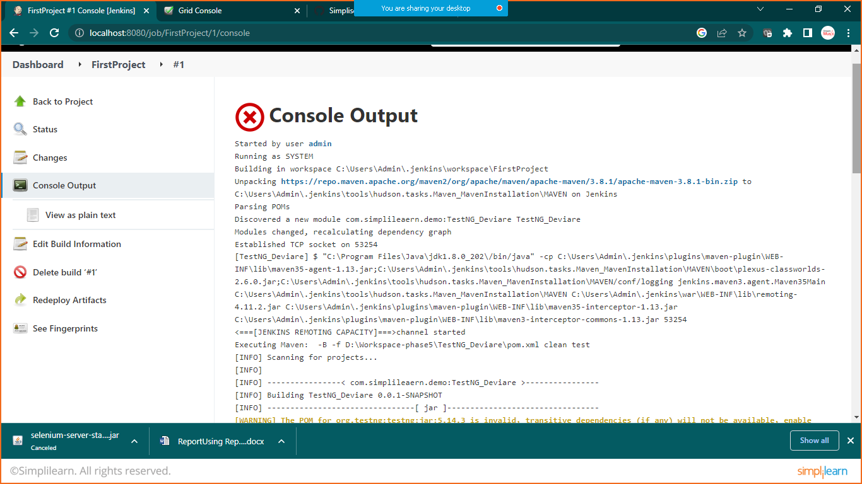

Check the result